**Research and Campaigns Management Report: Q3 – 2022 - 23**

**Report by:** Paul Clark

**Date:** 11/2/2023

**Research and Campaigns CAMV Staffing**

Christine Dixon – R&C Trustee

Paul Clark – R&C Lead

Lizzie Blair – R&C Researcher

**Update on Cost of Living (CoL) Crisis**

As you will be aware the R&C agenda has been dominated again with the CoL crisis. Though there was some good news after a lot of media coverage that the Government has advised energy companies not to force households in energy arrears to go on to PrePay meters. As far as we are aware the major energy companies have halted any court action to install prepay meters till the end of winter.

However, there is disturbing national evidence that many households are turning to credit cards to support themselves during the crisis. In the past 3 quarters Mole Valley has seen an increase in clients with debt issues.

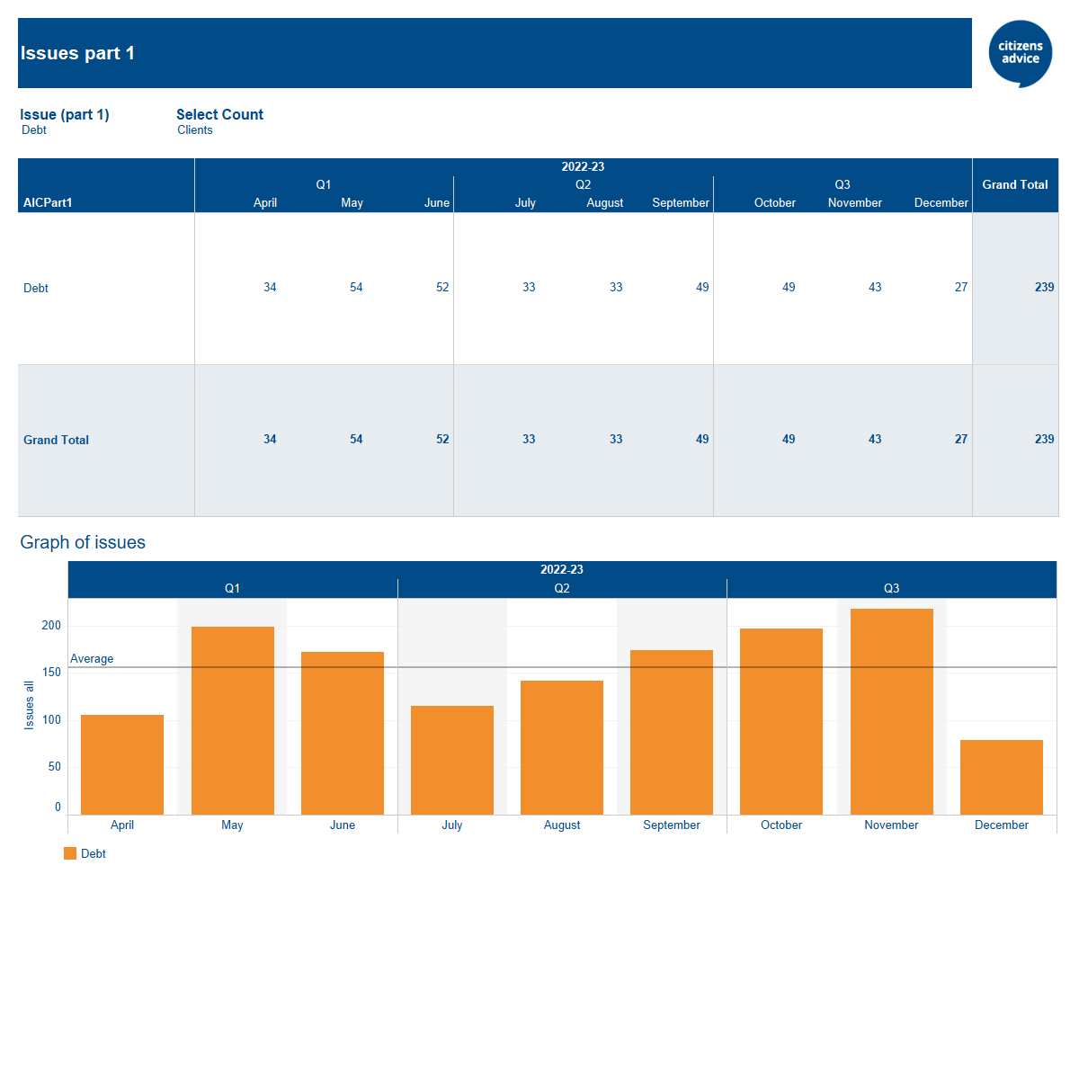

(Note that December figures are lower as traditionally clients do not come and see us on debt issues before Christmas and we are closed during the festive period)

**The top five Mole Valley client’s debt issues are:**

Council Tax arrears

Credit, Store and Charge card debt

Fuel debt

Rent Arrears (Hosing Association)

Water Supply and Sewage debts

Though not reflected at Mole Valley nationally 50% of clients who have come to see us on debt issues where a Income and Expenditure review was conducted they have no disposable income or even a negative income at the end of the month and therefore not able to service their debts.

144 clients came to see us requesting charitable support and/or food bank vouchers in Q3 which is a 12.6% increase from the previous quarter, again there is usually an increase in requests of this type in December.

**Surrey R&C Team**

We are still having bi-monthly meetings during the CoL crisis and they are being well attended. It seems that we are all seeing an increase in debt issues but also clients are coming in unable to find any affordable housing. The reasons for this may be two fold – firstly private rent in London has increased on average by 25% therefore residents in London are looking to move out of the city and move to the home counties. This has a knock on effect where housing in the home counties becomes scarce. Secondly the Government are not increasing Local Housing Allowance (LHA) despite the CoL crisis. The LHA provides housing benefit or Universal Credit Housing Element entitlement for tenants renting private-sector accommodation. The LHA for Mole Valley for a 2 bedroom flat is £947 pm having a quick look on the Right Move website the cheapest 2 bedroom flat in Dorking was £1250 pm. We have decided to do some more research on this and lobby CA that they should campaign on this issue.

**Evidence forms**

As I reported to Christine there were 55 evidence forms submitted in Q3 which is significantly increase on the 2 that was submitted the previous quarter. Not surprisingly the majority of issues were related to Col, such as rent increases in the private sector to people not receiving the Government vouchers to help with energy bills.

There was only one Calls for Evidence issued by CA concerning people on UC who work 15 hours a week will have to engage more with their Job Coach at the Job Centre to find extra hours and what effect this will have on the claimant.

**Meetings**

Paul has attended various online CA briefings and meetings over the reported period.